Johnson Lin

Professor Hu

MATH 347 - 51  
February 21, 2019

Lab 2

1. Exact solution: 0  
   Approximation by Monte Carlo: 0
2. Exact solution:   
   Lower bound is 8.725507  
   Upper bound is 8.77  
     
   Approximation by Monte Carlo:  
   Lower bound is 8.728969  
   Upper bound is 8.765969
3. 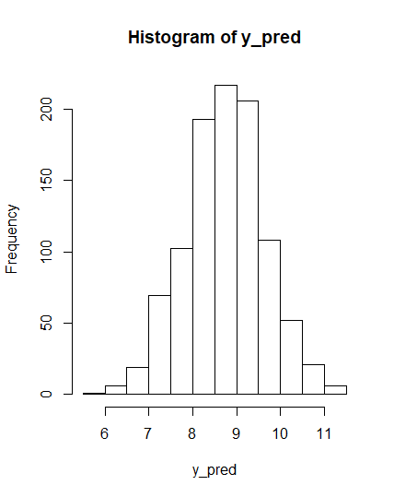
4. Prob(ȳ > ȳS | y) = 0.521  
   1 - Prob(ȳ > ȳS | y) = 0.479  
   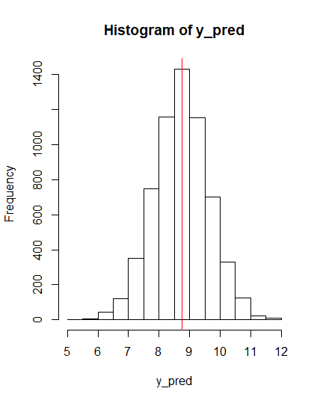

R code:

CEdata <- read.csv(file="C:/Users/Gorge-PC/Downloads/CEdata.csv", header=TRUE, sep=",")

CEdata$LogTotalExpLastQ = log(CEdata$TotalExpLastQ)

mu_0 = 5

sigma_0 = 1

phi_0 = 1/sigma_0^2

ybar = mean(CEdata$LogTotalExpLastQ)

phi = 1/var(CEdata$LogTotalExpLastQ)

n = 6208

mu_n = (phi_0*mu_0+n*phi*ybar)/(phi_0+n*phi)

sd_n = sqrt(1/(phi_0+n*phi))

### question 1

1 - pnorm(9, mu_n, sd_n)

set.seed(123)

S = 1000

sum(rnorm(S, mu_n, sd_n)>9)/S

### question 2

qnorm(0.025, mu_n, sd_n)

qnorm(0.975, mu_n, sd_n)

quantile(rnorm(S, mu_n, sd_n), c(0.05, 0.95))

### question 3

sample_sd = sd(CEdata$LogTotalExpLastQ)

mu_post = rnorm(S, mu_n, sd_n)

y_pred = rnorm(S, mu_post, sample_sd)

hist(y_pred)

###question 4

y_pred_matrix = matrix(rep(NA, S*n), ncol = n)

for (s in 1:S){

mu_post = rnorm(1, mu_n, sd_n)

y_pred = rnorm(n, mu_post, sample_sd)

y_pred_matrix[s,] = y_pred

}

ybar_sample = rowMeans(y_pred_matrix)

hist(y_pred)

abline(v=ybar, col = "red")

sum(ybar > ybar_sample)/s

1 - sum(ybar > ybar_sample)/s